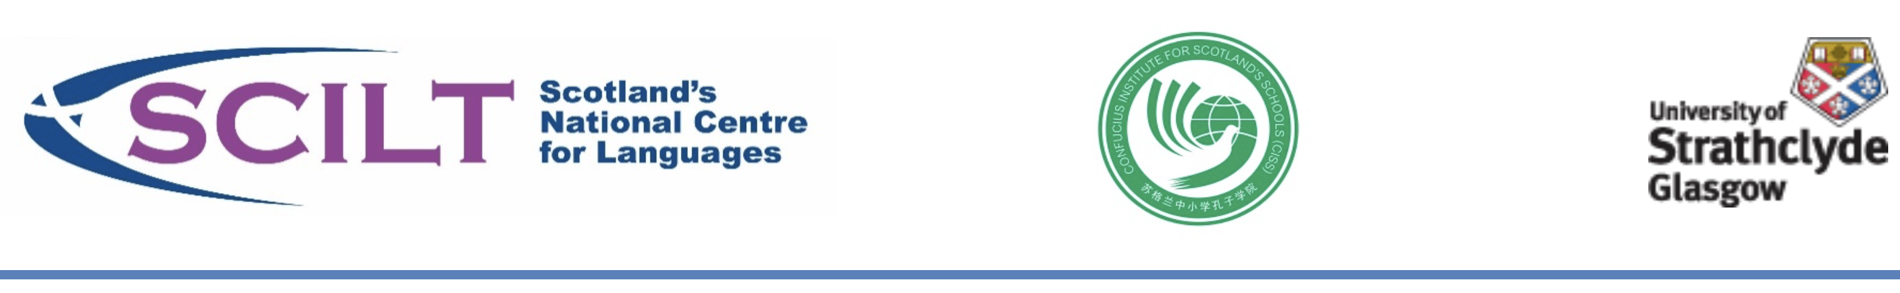

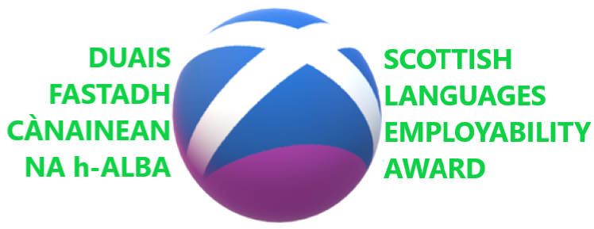

What is the Scottish Languages Employability Award?

The SCILT/CISS Scottish Languages Employability Award is an award which businesses and schools in Scotland achieve as partners. It is awarded by SCILT - Scotland’s National Centre for Languages and CISS – the Confucius Institute for Scotland’s Schools. The Scottish Languages Employability Award (SLEA) helps schools, and businesses and other organisations to build partnerships through languages in order to support teachers in developing young people’s learning about the world of work and their understanding of the value of language skills to their future employability.

The SLEA developed out of the highly successful SCILT/CISS Business Language Champions (BLC) scheme. Through the SLEA and BLC, SCILT/CISS has numerous Case Studies which Schools, Business and other partners can use for replicable ideas for projects. These projects build the partnership between schools, business and other partners and enable schools to deliver on Developing the Young Workforce and the National Improvement Framework, as well as build crucial partnerships outlined in How Good is Our School 4.

“Employers and schools need to develop strong two way partnerships – partnerships that deliver improvements to teaching and learning and bring real-life context into the classroom.”
Developing the Young Workforce (Scottish Government, 2014)

On successfully achieving a Scottish Languages Employability Award, Schools and their partner organisations will be awarded certificates for display and will be entitled to display the Scottish Languages Employability Award logo from the date of the confirmation of the award, for a period of up to two full academic years. Upon the end of this period, they will have to provide further evidence of continued school-business partnership in promoting languages in order to achieve another award.

What does the Scottish Languages Employability Award aim to do?

The aims of the Scottish Languages Employability Award are as follows

- Businesses and other organisations play an active role in shaping and benefiting from the education system at a local level, with a particular focus on languages
- Prepare young people for the world of work and help them to move successfully into the workforce
- Promote a positive awareness of businesses and organisations in their communities
- Gain fresh perspectives from young people
- Develop corporate social responsibility activities in an innovative way
- Harness and develop employees’ and volunteers’ language skills
- Raise awareness of the importance of languages for our economy and society

How schools and businesses can gain a Scottish Languages Employability Award:

Here are just some of the activities that businesses and other organisations could organise with schools to inspire language learners in your area:
- Talks to schools about how languages are important to the business or organisation
- Student and teacher visits to the business or organisation to see languages in action
- Provision of language mentors to support students in a local school or schools
- Development of employability projects for students in target languages
- Visits to business or organisation premises in Scotland
- Access to company/organisation resources and documents in target languages
- Any other activities which the school and their partner businesses and organisations feel will benefit both parties within the context of the Award.

A business-school partnership can involve more than one school and/or more than one business or organisation.

Scottish Languages Employability Award Toolkit

The Scottish Languages Employability Award can achieved at initial 3 levels, with a 4th level for partnerships who achieve continued innovation.

Scottish Languages Employability Award | Participation
Bronze | A project which involves 1 year group
Silver | A project (or range of projects) which involves 2 year groups
Gold | A project (or range of projects) which involves 3 year group
Platinum | Achieve a second successive Gold Award.

A Bronze, Silver and Gold Awards last for two full academic year from the end of the academic year in which it is awarded. Upon the end of this period, a school will have to provide further evidence of continued school-business partnership in promoting languages in order to achieve another award. Two successive Gold Awards will see the school awarded the Scottish Languages Employability Award – Platinum.

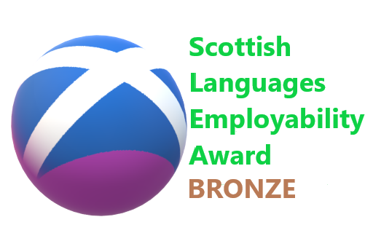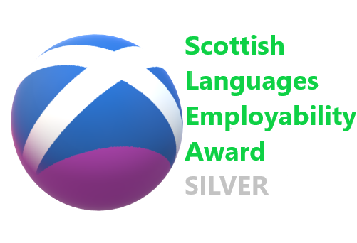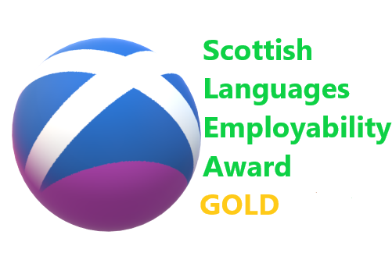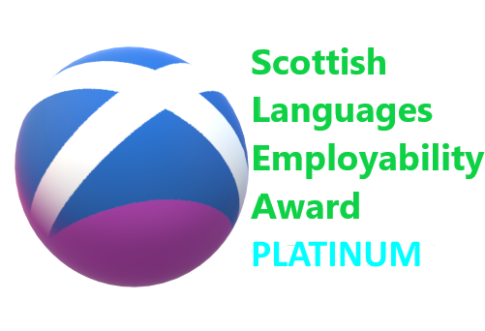

Gathering evidence
Your evidence can take many forms – e.g. photos, pictures, links to websites, collated feedback from participants, even audio-video evidence. (Please ensure that this is concise, is in a suitable accessible format, is audible and has all necessary permissions before sending to SCILT/CISS). You should fill in the

On completion of the award, submit your checklist by email to scilt@strath.ac.uk - Subject Scottish Languages Employability Award {School name}
Or you can post it to SCILT – Scotland’s National Centre for Languages, The Ramshorn, 98 Ingram Street, University of Strathclyde, Glasgow, G1 1EX, Tel: 0141 444 8163

Submission
Submissions to Award can be made at any time. Acknowledgement will be sent on receipt and your submission will be kept on record until the next verification and awarding round. There will be two submission deadlines per year. These will be advertised through SCILT channels.

Awarding decisions
Upon receipt of your evidence, SCILT/CISS will assess it and decide upon whether the school(s) and their partner(s) have achieved the Scottish Languages Employability Award. Awards will be granted, or otherwise, after a robust verification process by SCILT/CISS staff working collegiately to ensure that all establishments who receive the Award have achieved the necessary standard for the Award. You may be asked to provide further evidence. All decisions will be accompanied by feedback. SCILT/CISS will dispatch the Scottish Languages Employability Award within two weeks of a decision being made.

Presenting your SCILT/CISS Scottish Languages Employability Award
You may wish to do this it a whole-school event or at a local authority event. We would highly recommend that some of the participants take part in the presentation to talk about their experiences, and that a representative from the business partner is there as well.

Maintaining and displaying your SCILT/CISS Scottish Languages Employability Award
The school and its partners will be presented with a certificate, which they can keep and display permanently. However, all levels of the Award are time-limited in terms of their validation. Bronze, Silver and Golf Awards last for two full academic years from the end of the academic year in which they are awarded. Upon the end of this period, they will have to provide further evidence of continued school-business partnership in promoting languages in order to achieve another award. Two successive Gold Awards will see the school be granted the Scottish Languages Employability Award – Platinum on permanent basis.

During the time period described above, the school and its partners will be entitled to mention and display the relevant Scottish Employability Languages Award and its logo in their correspondence and other relevant places (e.g. in e-mail footers, in social media bios, etc).

More information about SCILT and the Award can be found here: https://scilt.org.uk/Employment/Developingskillsforlifeandwork/tabid/1597/Default.aspx

Linkages

The SCILT Scottish Languages Employability Award is relevant to these particular sections of How Good is Our School 4

1.2 Leadership of Learning
2.2 Curriculum
2.7 Partnerships
3.3 Increasing Creativity and Employability

The SCILT Scottish Languages Employability Award is relevant to the School/Employer Partnerships documentation for Developing Young Workforce and this documentation is useful for schools, employers and DYW groups & Local Authorities.

FAQs

How can my school achieve the Award without creating excess workload?
The SCILT Scottish Languages Employability Award (SLEA) is designed to help recognise the great work that is already being done in schools in Scotland towards promoting languages through employability. Whilst SCILT hopes to see many new, innovative projects and activities arise from this Award, it is important to reflect on the great work that is already happening and may contribute towards the award. For example, activities that you are already doing related to European Day of Languages, Scotland Loves Languages, or school trips etc. could all be included as activities that contribute towards this award.

Can SCILT help me find a business for my project?
SCILT created the SLEA on the basis that you know your local area and context for learning best. SCILT recommends that you first and foremost use this local knowledge and community to help you identify those. SCILT can provide further support via a wide range of examples of successful previous Awards, Business Language Champions, and other examples of innovation in Learning for Sustainability on our website which can help you develop your own ideas. {URL here}. We would also recommend that you contact your local authority DYW contact as well.

Is my school too small?
The Award has been designed in order that large schools and small schools can use it alike, across all sectors. The award is progressive and looks to encourage as wide a range of different ages to be involved in the activities that count towards the Award. If you are in a small school with a very small number of pupils (e.g. a one-pupil school) that may not meet the criteria of having two year groups involved, then please make this clear when filling in the toolkit and it will be taken into consideration.

We are a business, where do we start?
If you don’t have links with a school, then SCILT recommend that you first and foremost use your local knowledge and community in the first instance. Your staff may have children in local schools for example. Also, the DYW School/Employer Partnerships documentation highlights a great number of ways in which a business can contribute to working with a school partner an enriching the links between languages and employability. You can contact your local DYW Regional Group for further guidance as well.

We’re already involved in a partnership – do we need a new project?
Not at all. The Award aims to capture and award existing innovation. Go through the toolkit with your colleagues and partners and see if what you are doing already, or have recently completed, meets the criteria for the SLEA. We look forward to seeing your project evidence.
Information
Name of School
Address and Postcode

Contact Name and Position in School
Contact e-mail and phone number
School Roll |  | Target Year Groups of Project(s)
Project Title (if appropriate)
Date started |  |  | Date completed (if appropriate)
Has the School previously been involved in SCILT’s Business Language Champions scheme or the SCILT Scottish Languages Employabilty Award? | Yes No |  | If yes, please give dates, name of project and level of Award.
Partner organisation(s)

Contact at partner organisation(s)

Permissions | Please indicate if you are happy for your activities to be used as exemplification by SCILT and that all relevant permissions have been obtained according to your school policies. Yes No

Give a short description of your activities & projects (approx. 300 Words)

Checklist for Award

The following criteria, when evidenced, will allow a business-school partnership to be awarded the Scottish Languages Employability Award by SCILT - Scotland’s National Centre for Languages.

1. Planning | Evidence (with possible examples) – Evidence can be attached. | For SCILT/CISS use only
1.1 The school has identified and sourced partners, e.g. a local business, to develop a project in the target language(s) which brings skills for life and work into context. | e.g. name of partners
- The school and partners, e.g. a local business, have held an initial meeting to establish contact. | e.g. date of meeting, agenda
1.3 The school and the partners have both identified and chosen a named individual or individuals within their organisation to act as a point of contacts, as well as a back-up contact. | e.g. name of contacts, agenda
1.4 The partners have agreed to develop a project (or projects) for students in in the target language(s) to be taken forward by the students. It is appropriate to the level of the students involved, has an element of student choice in regards to the nature of the project and is relevant to the work of the partners’ operations. | e.g. a plan of the project with approximate timings, E&O links, agenda
1.5 The project has clearly defined and agreed expectations related to the relevant Curriculum for Excellence Experiences and Outcomes and the Career Education Standard Entitlements, and signed off by representatives of all partners. | e.g. a signed plan of the project
1.6 The project has been launched jointly by school and partners with appropriate publicity with recognition given to the SCILT/CISS Scottish Languages Employability Award | e.g. Screenshot of School/Partner Social Media, press cuttings

2. Outreach & Learning | Evidence | For SCILT/CISS use only
2.1. The Partners have facilitated a visit by learners and teachers to the organisation’s premises (where workplace is appropriate) to learn about their work and also to see and hear languages in action.  And/Or  The Partners has sent in a representative or representatives to the school to discuss their organisation in general and the importance of languages to them for the learners. | e.g. photo, leaflets, presentation slides
2.2 The School and partners have publicised the visit project appropriately, giving recognition to the SCILT/CISS Scottish Languages Employability Award. | e.g. Screenshot of School/Partner Social Media, minutes, press cuttings
2.3 Learners in the school are inspired by the visit to take forward the project within their school and completing it through activities linking employability and languages. | e.g. feedback forms, examples of materials, pictures, numbers of participants
2.4 Activities
A short description of the activity, the outcomes, the year groups and number of learners involved. Schools have flexibility in the number of activities that they may wish to do in order to achieve the award. The range and number of participants in these activities and the quality of the experience is what is important.
2.4.1 Activity One | e.g. pictures, a pupil report, feedback forms, posters.
2.4.2 Activity Two (if applicable)
2.4.3 Activity Three (if applicable)
2.4.4 Activity Four (if applicable)
2.4.5 Activity Five (if applicable)
2.5 The School and Partners have collected feedback from the participants for reflection and to inform next steps. | e.g. feedback forms

3. Legacy | Evidence | For SCILT/CISS use only
3.1 The School(s) have developed a culture where learning languages is more valued. | e.g. learner feedback forms, staff feedback forms
3.2 The partners have agreed to use any materials or resources produced in the project, where appropriate. | e.g. examples of the materials, resources
3.3 The partners engage with and demonstrate an awareness and appreciation of the languages used by its customers, stakeholders, associates and communities. | e.g. feedback forms from the partner organisation(s)
3.4 The Partners have discussed and planned future steps, and planning is in place for the following year’s project. | e.g. agendas, minutes of meetings, feedback forms,
3.5 The overall project is publicised via a public forum on a whole school basis giving recognition to the SCILT/CISS Scottish Languages Employability Award. | e.g. press clippings, screenshots, url links

Signed by School | Name | Date
Signed by Partner Organisation | Name | Date
Signed off by SCILT/CISS | Name | Date

For SCILT/CISS use only – Comments and Feedback

Level of Scottish Languages Employability Award awarded and date awarded.

Bronze |  | Silver |  | Gold

Bha Duais Fastadh Cànainean na h-Alba air a leasachadh agus ga toirt gu buil le taic-airgid o Bhòrd na Gàidhlig agus GLAIF (Gaelic Language Act Implementation Funding).

The Scottish Languages Employabilty Award was developed and implemented with support from Bòrd na Gàidhlig and the Gaelic Language Act Implementation Fund.

